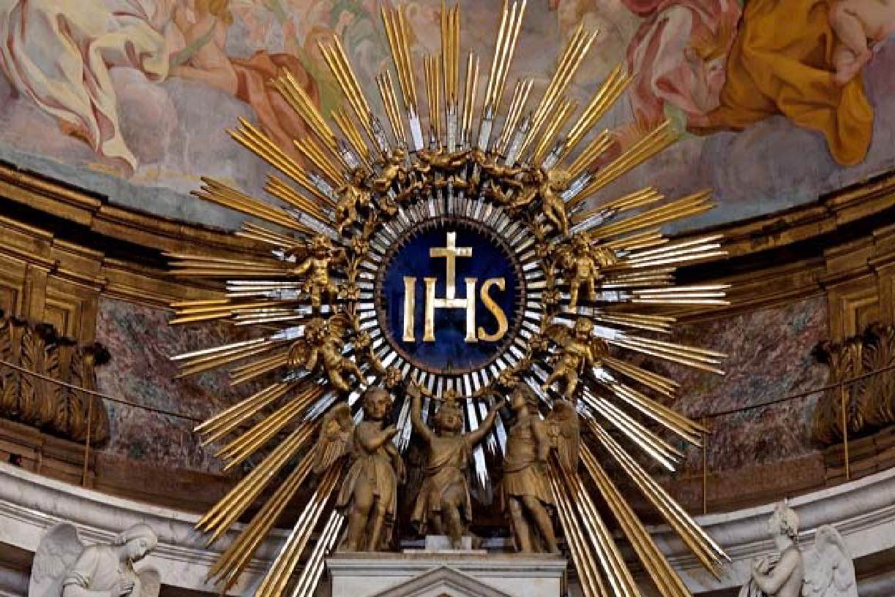
“I Decided to Bow My Head at the Name of Jesus
By Br. Isidore Rice, O.P. January 3, 2019
I decided to bow my head at the name of Jesus. I wish I could say I was led to this by feelings of pious devotion. I was not. I just saw some priests doing it and it seemed like a good idea; we call His name holy after all. So, I decided to bow my head at the name of Jesus.
I wish I could say my motives were perfectly pure, but honestly, I hoped to be seen. When I bowed my head at the name of Jesus, certainly someone would take note, and they would think me quite pious and holy. Not everybody bows their head at the name of Jesus, you know. That’s not why I did it, at least not usually, but the thought was not displeasing to me. But I decided to bow my head at the name of Jesus.
The name of Jesus comes up a lot in Mass. At first, I usually missed my chance to bow my head. I had to start listening, to start noticing. After all, I had decided to bow my head at the name of Jesus. It always comes up twice in the Gloria, once in the Creed. After the Our Father, it comes at the end of the priest’s prayer and then he says it again right away after “the kingdom the power and the glory...” You can get on a roll at that part.
Depending on the Eucharistic Prayer, the number of opportunities varies. If I listened at the beginning, I could know which one it was and when to bow; I had decided to bow my head at the name of Jesus. It always comes up soon before the consecration. That is really neat; I’ll have to think more about that. I like it best when it comes up right before the doxology—“through Him with Him and in Him”—culminating it all. The Collect and Preface are tricky. Sometimes you get the name of Jesus, sometimes just “Christ” or “Son.” Should I bow my head at “Christ”? If I do, it can’t hurt, but I had decided to bow my head at the name of Jesus. What about the readings and the homily? Some priests say the name of Jesus a lot when they preach (I hope I’ll be one of those). In the meantime, though, I could end up looking like a bobble head. What will people think? Does it matter? I have decided to bow my head at the name of Jesus.
The name Jesus means God saves. It’s hard to find a better summary of the Gospel than that. Scripture talks a lot about God’s name: I am who I am; the Almighty has done great things for me and holy is His name; at the name of Jesus very knee shall bow; Hallowed be thy name. I like that. It directs us to what is most important, what is most wonderful, what is most true. When I hear that name now, I might even be touched with thoughts of pious devotion. I decided to bow my head at the name of Jesus.
✠ Discussion ✠
Br Isidore’s comments are a great way to focus during the mass. I am always susceptible to a wandering mind. So this is great for me. Some of you use the Magnificat as a way to follow along and keep focused. This is also great. For those without a subscription to this booklet you can email https://bookstore.magnificat.net/subscription/index for a subscription.
The second point on this paper I’ll comment on is “about looking like a bobble head”. Eyesight, both yours and of those around you is not immutable. What is seen CAN, in reality, vary. Is this by prayer only? Comments?
This discussion is not about the second commandment. As such, I would quickly mention that thousands of vulgar words strung together are insignificant and may get you a single day in purgatory for saying them, BUT to the use of God’s Name in vain where a single use carelessly may get you a thousand years in purgatory. We use “diarrhea” casually, yet sh_t is appalling. The words mean the same thing. So our consensus on vulgar words is just that, us agreeing on something. The NAME of God is totally different. There was no consensus between us and God. God even devoted an entire commandment to His name. In ancient times knowing a person’s name meant that you owned them. Today, the comparison is like a SS number. If I have your number I can control your life. If Herod knew Joseph’s name he could have just sent his soldiers out to kill only Jesus saying, “go get the family of Joseph Carpenter of Nazareth and kill the family”.
Respect for the Name of God such as bowing one’s. head , in my opinion, is a “Prayer Booster” like a vitamin. I like the term “spiritual exercises” better , but St Ignatius took that already. We know that prayer boosters exist because Jesus said they do. He said that the evil spirit that the apostles could not cast out could only be done with prayer AND fasting. So fasting is a prayer booster. Fasting alone does nothing since there are no automatic saints in countries without enough food. Why are the prayers of some people more powerful? Answer: prayer boosters. Boosters are additive and have power only when added to prayer. Jesus did not say that fasting was required specifically at the moment the apostles prayed for a healing on someone. So, a Saint like Padre Pio, who fasted regularly had very powerful healing prayers at all times. He had the benefit of many, many prayer boosters. Comments? Boosters go beyond keeping commandments.
Other booster examples - Bless yourself driving by a church- Fast by using one sugar instead of two in your coffee - accept some offense or inconvenience - Pray with another person. Ask your guardian to suggest specific boosters for you. I ask that my angel repeat the suggestions because my hearing is bad. We have talked about many, many of these boosters - remember the ones in the lay preaching module? Who can name one? Boosters are not prayers and not commandments by themselves but act to intensify all your prayers.
Name of God Historically:
There is an absolute importance to keeping ALL forms of the Name of Jesus and God holy. This may seem obvious, but as I look at myself, I see a real lax attitude regarding use of phases like OMG or holy this or holy that. Not only is it SO important as to be a commandment, but in the bible the Jewish people were never allowed to even write the Name of God. They could say it but not write lest the page it was written on be destroyed or even laid on the ground! Comments?
The God of the Hebrew Bible has many names. Most common is YHWH. It occurs over 6,500 times.. YHWH is referred to as the Tetragrammaton (which simply means "the four letters"). YHWH comes from the Hebrew letters: Yud, Hay, Vav, Hay. since Hebrew script originally contained no vowels. JHWH is explained in the book of Exodus as “I am Who I am” and it is clearly derived from the old Hebrew verb HWH which means “to be.” The term “Jehovah” was introduced by Christian scholars. It is merely JHWH pronounced with the vowel of Adonai, thus making JeHoWaH. While YHWH is first used in Genesis 2, God did not reveal Himself as YHWH until Exodus 3. The modern spelling as "Yahweh" includes vowels to assist in pronunciation. Many pronounce YHWH as "Yahweh" or "Jehovah." Nothing in the Torah prohibits a person from pronouncing the Name of God. Indeed, it is evident from scripture that God's Name was pronounced routinely. However it is worth noting that we no longer know for certain this pronunciation. During the third century A.D., the Jewish people stopped saying this name in fear of contravening the commandment "Thou shalt not take the name of the LORD thy God in vain", thus the correct pronunciation is lost forever! My personal observation would be that God told Moses to tell the Egyptians, “ “I Am Who Am” sent you”. The Egyptians were pagans, so I doubt that the name of God given to the chosen people is the same as the one given to pagans. Comment?
All is not lost however since Jesus instructed us to call God “Father”. The name Abba or Father is the word for God in the Lord's Prayer (Luke 11:2) The epithet is strikingly frequent in John (108 times) and also in Matthew (40 times). The range of meanings includes those of authority and discipline, but also those of compassion, care, protection, and provision. The name Father is further supported at Fatima, as Mary joined the children in the “glory be” AND more recently in divine mercy where we implore God as Father.
Joan of Arc has an inspiring story connected closely with using the Name of God superfluously. A video clip is included in the study package on the website. Who has looked at this and do you have a comment?
Holy Name Devotion - The Council of Lyons in 1274 emphasized the need for the faithful to have a special devotion to the Holy Name of Jesus. The Dominicans, who were actively spreading the Christian message at this time in a crusade against the Albigensians, took on the challenge and preached the power of the Holy Name of Jesus. They spread the devotion extremely effectively. In every Dominican church, altars, confraternities and societies were erected everywhere in honor of the Holy Name. The Dominican Order continues to lead the Holy Name Society.

Notes from the vault: [as we have discussed at previous meetings, please don’t take words of any mystic as absolutely literal. Any revelation can be tainted by personal literacy – remember our previous discussion on this? – Comments? YouTube lately?
- On July 24, 1982, the Blessed Mother said: ‘We go to Heaven in full consciousness of the separation of the body and soul. It is false to teach people that we are reborn many times and that we pass to different bodies. One is born only once. [aka 1-2 billion Hindus, third largest world religion are WRONG] The body, drawn from the earth, decomposes after death. It never comes back to life again. Man receives a transfigured body.
- Whoever has done very much evil during his life can go straight to Heaven if he confesses, is truly sorry for what he has done, and receives Communion at the end of his life.’ [ NOTE that she does not say perfect contrition! Is this noteworthy? ]
- Our Lady said that the souls in Purgatory can see their loved ones during those moments when we pray for them by name.”
- Angels return to their place before the throne of God by simply saying HIS name.

